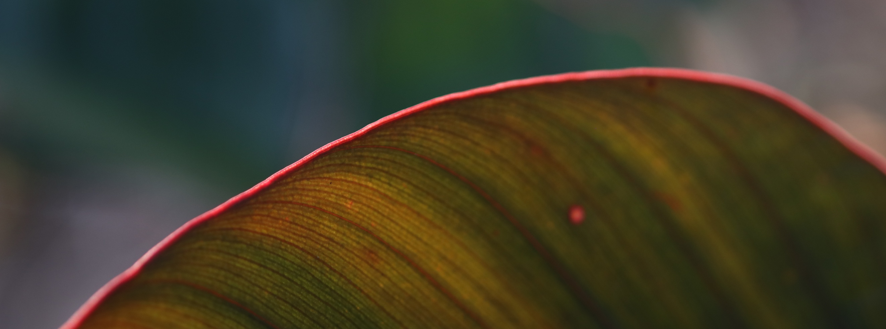

Volunteering

Milperra State High School
Art Room volunteer
  - Term 3, 2019
YWAM Medical Ship Missions Trip
  - April 2018
Create Foundation
Volunteer Art Workshop
  - 2015
Belconnen Arts Centre
Volunteer Assistant
  - 2015

Artist & Educator

Rachaelbrooke.com | rachaelbrookeart@gmail.com

RACHAEL HARRIS

Education

Master of Teaching
Queensland University of Technology
Specialising in Visual Art and English
  - February 2019 - November 2020
Bachelor of Visual Art
Australian National University
Glassmaking Workshop Major
  - February 2015 - November 2017
Diploma of Visual Art
Canberra Institute of Technology
  - January - November 2014

Education

Exhibitions

2023 Glass Meet the Future Film Festival 2023 Commission, Northlands Creative, Scotland: https://northlandscreative.co.uk/gmtf-2023-homepage /
2022 Diaphanous Dreaming, Land Street Gallery, Brisbane
2021 Glass Meet the Future Film Festival 2021, Northlands Creative, Scotland
2021 The Edge, Richard Randall Art Studio, Mount Coot-Tha Botanic Gardens, Brisbane
2020 Glass Meet the Future Film Festival 2020, Northlands Creative, Scotland
2019 Closer, Australian National Botanic Gardens, Canberra
2018 National Emerging Art Glass Prize, Wagga Wagga Art Gallery
2017 Graduating Exhibition, ANU School of Art and Design, Canberra
2016 Love is in the Air, CCAS Members show, Canberra Contemporary Artspace,
Canberra
2015 Hidden Treasures, Belconnen Arts Centre Group Exhibition, Canberra
2014 CIT Visual Arts Diploma Exhibition, Reality Reversed, Canberra
2014 Selfie CCAS Members show, Canberra Contemporary Artspace, Canberra
2011 ‘Our Nation’s Garden’ Schools Photographic Competition, Australian National Botanic Gardens, Canberra

